Instructions for Tube Sets

Importance of Changing Tube Sets
- Infection Prevention: hard water deposits could potentially build up on inside surface of the tube set.
- Reduced flow rate: the squeeze tube can lose its elasticity with time and use
- Reduced pump life: the factory-applied tube set lubricant eventually wears away, resulting in more resistance and more work for the pump. This can reduce the pump’s overall useful life.

Each tube set will have a 30 day timestrip® attached.
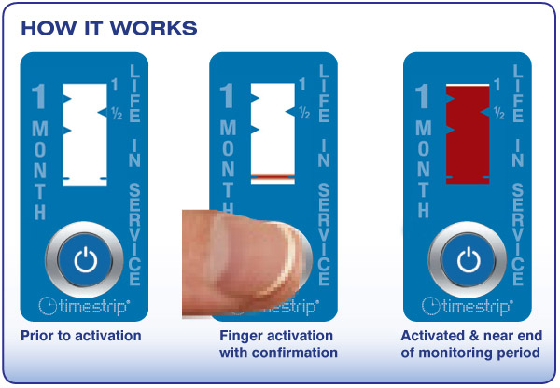

As a best practice solution, when changing tube sets always write your initials and expiration date on the back of the timestrip® label.

Initials:
Expiration Date:

Changing Tube Sets

How to Change Tube Set
- Remove Pump Housing – Disconnect power supply from wall, and press tabs to release pump cap from base. Remove top and tube assembly as shown.
- Remove Old Tube Set – Turn pump cap upside down and remove tube set with rotor. Observe the orientation of the tube fitting for proper re-assembly. Refer to drawing for correct orientation of components.
- Re-Thread New Tube Set – Remove tube set from rotor and discard. Take the new tube set and wrap it around the pump rotor. Place assembly back into pump top cap and clip down. Make sure the 3 tube leads are on the right while tube set is face up (see picture 3 below)
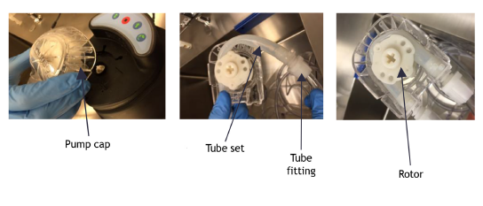
Change tube set every 30 days!

